Lab Objective

Learn how to Using Folder Redirection

**Lab Procedures**

Log in to Server01 as the **Contoso\Administrator** user account with the password of **Password01**. The Server Manager console opens.

**2.** On Server01, create the C:\UserData folder.

**3.** Right-click the C:\UserData folder and click Properties. The Properties dialog box opens.

**4.** Click the Sharing tab and click Advanced Sharing. The Advanced Sharing dialog box opens.

**5.** Click Share this folder. Click Permissions. Click Allow Change permission for Everyone

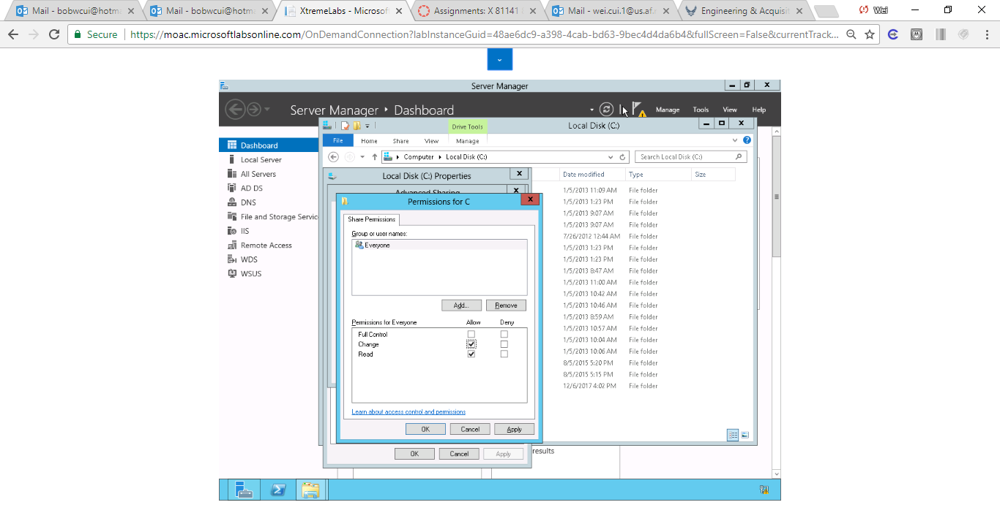

Figure Screenshot shows change permission has been granted to everyone.

**6.** Take a screen shot of the Permissions for UserData dialog box by pressing Alt+Prt Scr and then paste it into your Lab20_worksheet file in the page provided by pressing Ctrl+V.

**7.** Click OK to close the Permissions for UserData dialog box and click OK to close the Advanced Sharing dialog box.

**8.** Click Close to close the UserData Properties dialog box.

**9.** On RWDC01, using Group Policy Management Editor for GPO7, navigate to the \User Configuration\Policies\Windows Settings\Folder Redirection node.

**10.** Right-click the Documents folder in the left window pane and select Properties. The Documents Properties dialog box opens as shown in Figure 20-2.

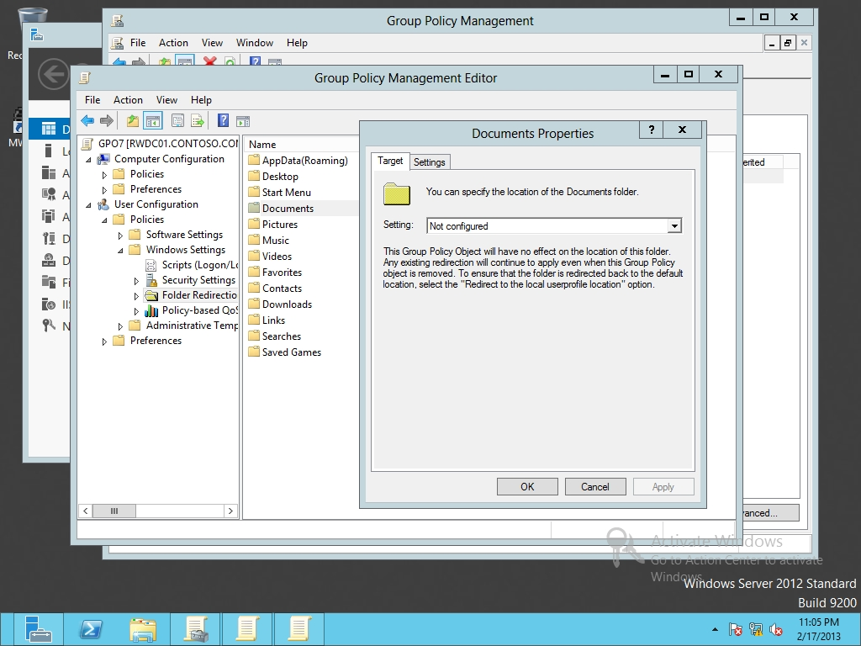

Figure 20-2

Redirecting the Documents folder

**11.** Under Setting, click *Basic – Redirect everyone’s folder to the same location* as shown in Figure 20-3. Under Root Path, type **\\server01\UserData**.

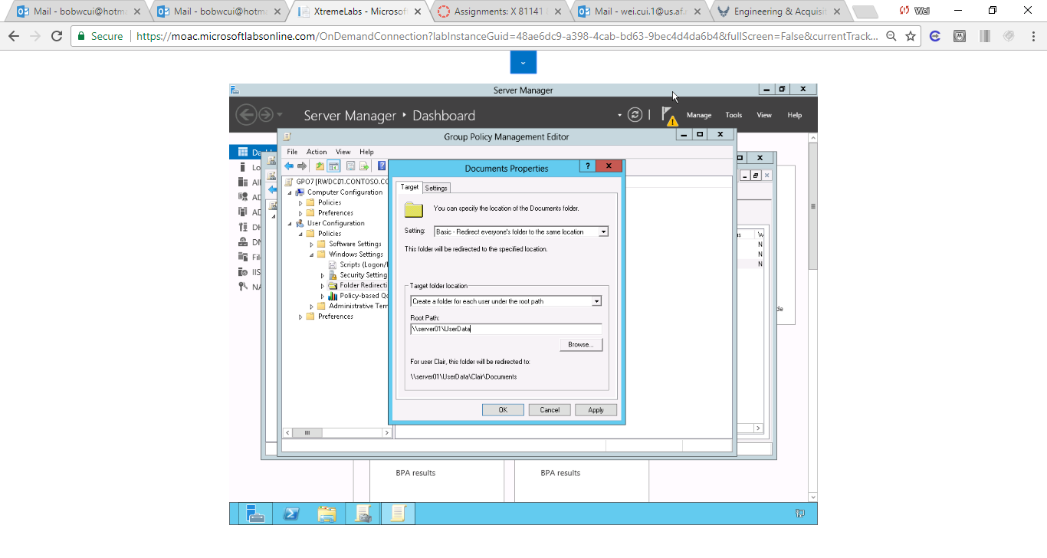

Figure Selected Basic – Redirect everyone’s folder to the same location.. Under Root Path, typed \\server01\UserData

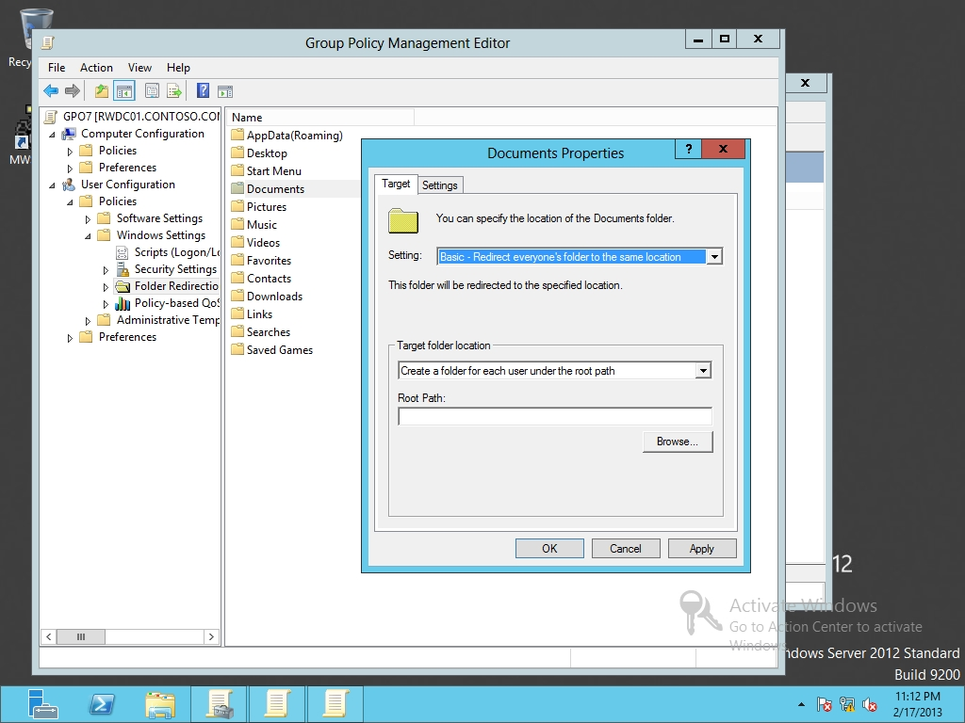

Figure 20-3

Selecting basic redirect

|  |  |
| --- | --- |
| Question 3 | If JSmith logs in, where would his Documents folder be located? |

**12.** Click OK to close Documents Properties dialog box. If a warning appears asking if you want to continue, click Yes.

**13.** Keep the Group Policy Management Editor window open for the next exercise.

End of exercise.

**Lab Summary**

During this exercise, you create a UserData folder on a server and redirect the user’s Documents folder to the UserData folder.